**Control chart Patterns Recognition Using Convolutional Neural Network**

**Data Visualization**

For the given eye tracking gaze point datasets, I have done Data Simulation using monte carlo simulation on approx **10,944 raw eye datasets** and prepare **87,552 datasets** with **8 different patterns** **using Monte carlo simulation**

|  |  |  |
| --- | --- | --- |
| Recording timestamp | **Gaze point X** | **Gaze point Y** |
| 0 | 837 | 624 |
| 10 | 836 | 627 |
| 20 | 836 | 633 |
| 30 | 834 | 643 |
| 40 | 832 | 649 |
| 50 | 831 | 658 |
| 60 | 830 | 659 |
| 70 | 829 | 659 |
| 80 | 828 | 664 |
| 90 | 828 | 668 |
| 100 | 827 | 673 |
| 110 | 823 | 682 |
| 120 | 821 | 686 |
| 130 | 820 | 686 |
| 140 | 817 | 686 |
| 150 | 823 | 690 |
| 160 | 902 | 717 |
| 390 | 946 | 743 |
| 400 | 954 | 750 |
| 410 | 959 | 750 |
| 420 | 963 | 750 |
| 430 | 967 | 750 |
| 440 | 972 | 748 |
| 450 | 976 | 747 |
| 460 | 980 | 747 |
| 470 | 986 | 747 |
| 480 | 992 | 747 |
| 490 | 994 | 744 |
| 500 | 996 | 744 |
| 510 | 1000 | 745 |
| 520 | 1003 | 745 |
| 530 | 1010 | 748 |

For Monte carlo simulation I have take the simulation length equal to 32 time spans i.e

I have done data simulation for each 32 datasets of 10944 raw eye data and with each 32 datasets I have prepared datasets for 8 different patterns by changing different parameters given below:

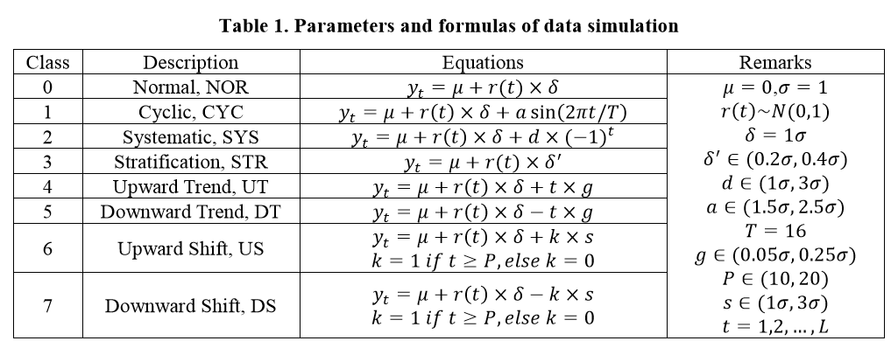

Here I have shown the graph of each pattern from the datasets generated using Monte carlo simulation for 32 datasets of raw eye data.

1. **Normal Pattern**

|  |  |  |
| --- | --- | --- |
| **Recording timestamp** | **x point** | **y point** |
| 0 | 974.7703585 | 746.4888028 |
| 10 | 978.1139753 | 748.4581902 |
| 20 | 916.2895828 | 712.0436766 |
| 30 | 936.2671942 | 723.8104723 |
| 40 | 952.8424415 | 733.5732786 |
| 50 | 935.2824468 | 723.230457 |
| 60 | 953.1225468 | 733.7382604 |
| 70 | 964.372857 | 740.3646834 |
| 80 | 964.8129035 | 740.6238704 |
| 90 | 925.9737761 | 717.747658 |
| 100 | 944.9172256 | 728.9053334 |
| 110 | 935.8536881 | 723.5669176 |
| 120 | 965.411795 | 740.976617 |
| 130 | 965.1669067 | 740.832378 |
| 140 | 928.2914882 | 719.1127885 |
| 150 | 969.9176912 | 743.6305859 |
| 160 | 918.3874413 | 713.2793134 |
| 390 | 957.2895875 | 736.1926438 |
| 400 | 929.7390389 | 719.9653945 |
| 410 | 938.7750093 | 725.2875733 |
| 420 | 919.9023355 | 714.1715848 |
| 430 | 959.4562859 | 737.4688273 |
| 440 | 967.5373209 | 742.2285499 |
| 450 | 947.0624972 | 730.1688965 |
| 460 | 945.334794 | 729.1512808 |
| 470 | 977.5727342 | 748.1393997 |
| 480 | 906.2982939 | 706.158816 |
| 490 | 949.2871727 | 731.4792284 |
| 500 | 935.9829389 | 723.6430462 |
| 510 | 941.5278309 | 726.9089828 |
| 520 | 966.3723555 | 741.5423863 |
| 530 | 910.9314249 | 708.8877262 |

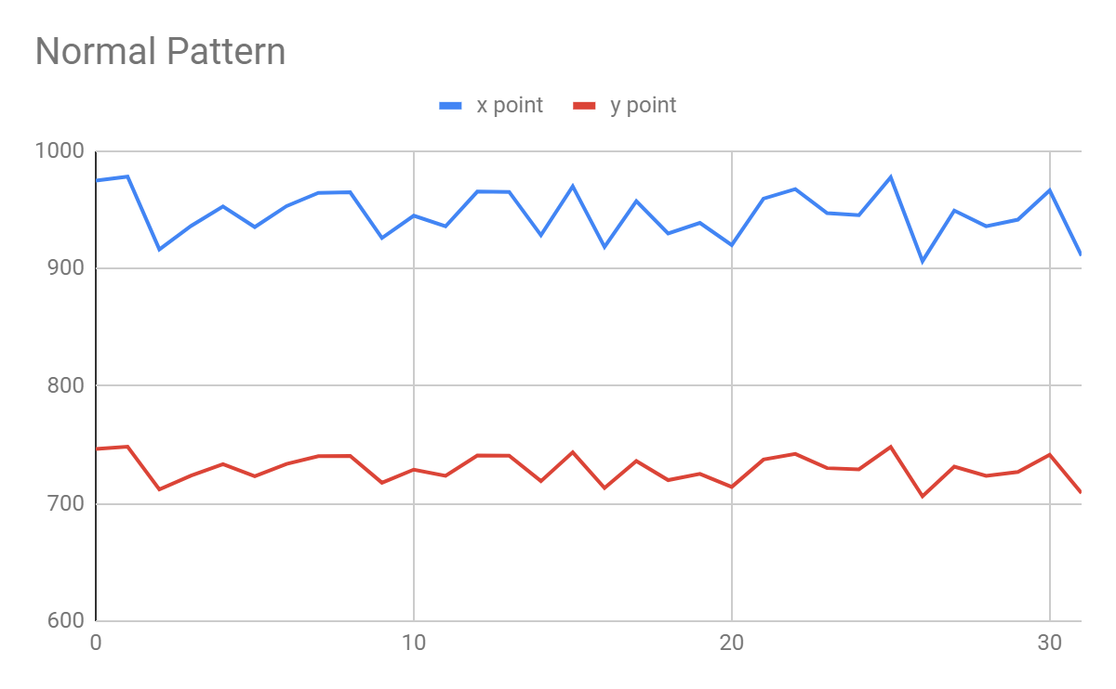

1. **Cyclic Patterns**

|  |  |  |
| --- | --- | --- |
| **Recording timestamp** | **x point** | **Y point** |
| 0 | 994.9611463 | 761.7218503 |
| 10 | 977.0244203 | 757.7463024 |
| 20 | 1016.024761 | 778.1192101 |
| 30 | 1067.655992 | 806.146568 |
| 40 | 1089.815529 | 807.459615 |
| 50 | 1072.712875 | 789.1377802 |
| 60 | 1081.618842 | 826.871352 |
| 70 | 1067.661005 | 824.7160675 |
| 80 | 1133.386111 | 819.365626 |
| 90 | 1059.532966 | 815.7454236 |
| 100 | 1097.129116 | 824.0999627 |
| 110 | 1087.331562 | 816.3369479 |
| 120 | 1053.682604 | 778.2126746 |
| 130 | 960.7061953 | 735.1775235 |
| 140 | 941.3219047 | 730.4850587 |
| 150 | 938.3933981 | 725.0628046 |
| 160 | 912.9381541 | 708.6205916 |
| 390 | 836.4447177 | 663.7465254 |
| 400 | 799.7525209 | 658.1059418 |
| 410 | 850.9000662 | 670.9786148 |
| 420 | 791.3564454 | 638.717299 |
| 430 | 844.3736535 | 661.9481753 |
| 440 | 838.0365874 | 664.756879 |
| 450 | 744.5121498 | 620.5990155 |
| 460 | 786.6721893 | 627.5129878 |
| 470 | 827.1501718 | 666.2290644 |
| 480 | 767.0347537 | 618.3625453 |
| 490 | 860.5240652 | 672.0625528 |
| 500 | 840.483234 | 661.7715243 |
| 510 | 855.6283027 | 682.1129419 |
| 520 | 885.1456375 | 696.1557392 |
| 530 | 955.0447715 | 734.8704491 |

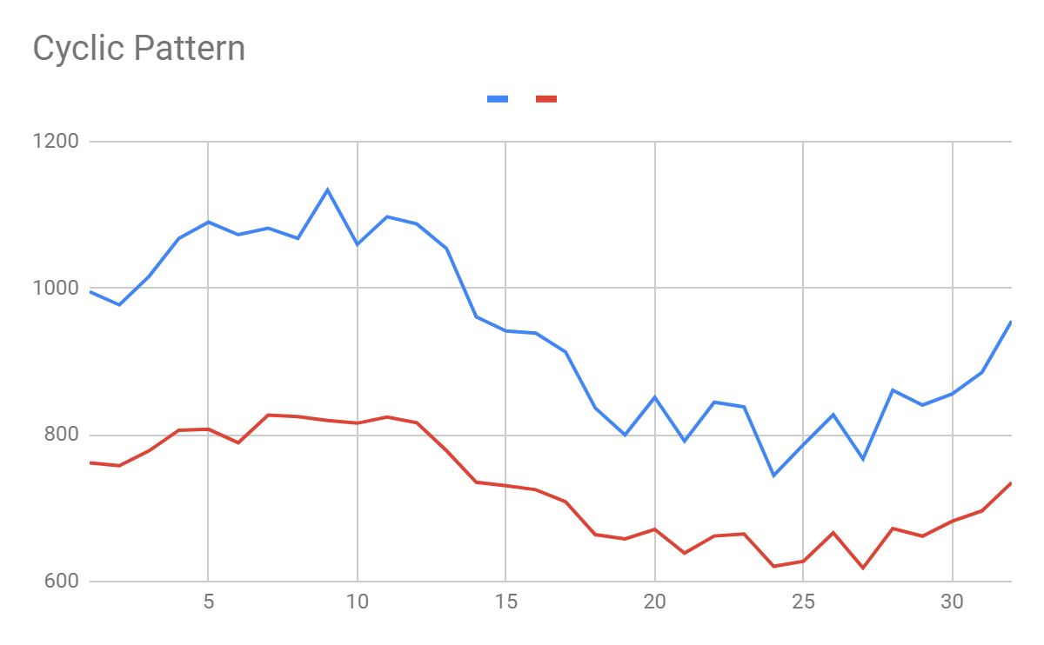

1. **Systematic Pattern**

|  |  |  |
| --- | --- | --- |
| **Recording timestamp** | **X point** | **Y point** |
| 0 | 798.9438454 | 581.7077798 |
| 10 | 1127.290642 | 840.245177 |
| 20 | 793.4116448 | 692.2980172 |
| 30 | 1138.404062 | 823.3593912 |
| 40 | 843.5839291 | 671.3126228 |
| 50 | 1153.148786 | 814.5601519 |
| 60 | 718.075144 | 595.000126 |
| 70 | 1046.592121 | 838.6892605 |
| 80 | 884.3635809 | 658.7686428 |
| 90 | 1150.038102 | 782.153567 |
| 100 | 822.4992942 | 647.0914809 |
| 110 | 1062.684511 | 845.1559369 |
| 120 | 800.2332927 | 670.60827 |
| 130 | 1050.392303 | 845.0982048 |
| 140 | 826.1325098 | 616.6959402 |
| 150 | 1180.6411 | 874.4599671 |
| 160 | 758.2201917 | 633.1502428 |
| 390 | 1122.59924 | 779.9948875 |
| 400 | 826.3450839 | 613.3607481 |
| 410 | 1049.990778 | 822.2316981 |
| 420 | 763.4962737 | 654.6195053 |
| 430 | 984.9017937 | 762.7077554 |
| 440 | 763.3882168 | 686.0031762 |
| 450 | 1044.493801 | 781.9170938 |
| 460 | 747.7034243 | 602.3986445 |
| 470 | 1096.320583 | 797.2613793 |
| 480 | 759.2804102 | 665.2567805 |
| 490 | 1001.261432 | 797.4673162 |
| 500 | 809.1552063 | 584.6102298 |
| 510 | 1035.275881 | 807.1871799 |
| 520 | 745.6766508 | 641.1013062 |
| 530 | 1103.252317 | 764.5915864 |

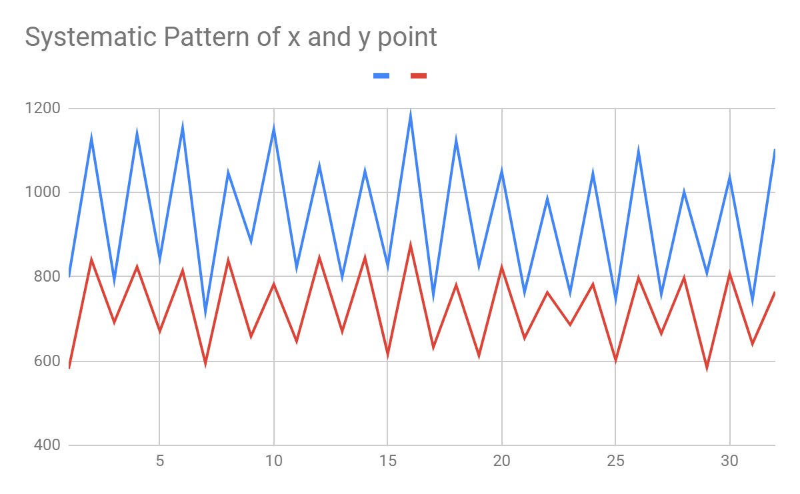

1. **Stratification Pattern**

|  |  |  |
| --- | --- | --- |
| **Recording timestamp** | **X point** | **Y point** |
| 0 | 915.4579011 | 708.0584668 |
| 10 | 907.646187 | 707.4161648 |
| 20 | 907.9544894 | 708.0369946 |
| 30 | 905.9840037 | 705.6737194 |
| 40 | 918.702387 | 717.0340573 |
| 50 | 905.1473713 | 704.5587865 |
| 60 | 915.8412668 | 715.0075211 |
| 70 | 920.7854387 | 712.8512827 |
| 80 | 922.2699869 | 715.4609142 |
| 90 | 904.8002944 | 704.5918991 |
| 100 | 902.7228116 | 703.8144646 |
| 110 | 916.5570214 | 716.9727687 |
| 120 | 909.2491227 | 706.9449754 |
| 130 | 902.2968426 | 703.84293 |
| 140 | 902.2229188 | 703.7407659 |
| 150 | 903.2310948 | 704.2864353 |
| 160 | 902.5148581 | 704.2410346 |
| 390 | 909.9025403 | 707.9931344 |
| 400 | 902.5724581 | 704.1526091 |
| 410 | 921.2131907 | 713.1393259 |
| 420 | 921.1820607 | 718.1071165 |
| 430 | 914.4517672 | 713.3257464 |
| 440 | 911.4554638 | 710.4517795 |
| 450 | 918.3946428 | 711.8376254 |
| 460 | 904.7467331 | 704.8167705 |
| 470 | 916.7459793 | 709.2183134 |
| 480 | 908.6373807 | 709.8607026 |
| 490 | 909.7349378 | 707.7134019 |
| 500 | 914.0914037 | 710.1533444 |
| 510 | 922.7634636 | 712.3590779 |
| 520 | 910.5507174 | 707.5663508 |
| 530 | 904.9702035 | 705.0606094 |

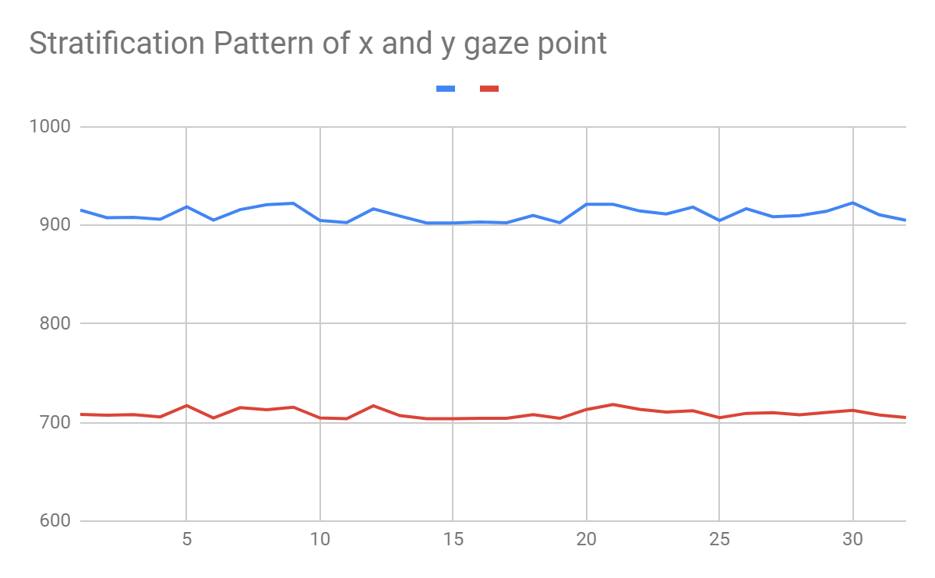

1. **Upshift Patterns**

|  |  |  |
| --- | --- | --- |
| **Recording timestamp** | **X point** | **Y point** |
| 0 | 903.4092487 | 704.4571709 |
| 10 | 920.4394724 | 714.4879579 |
| 20 | 920.4404638 | 714.4885419 |
| 30 | 927.8005123 | 718.8236041 |
| 40 | 973.4714186 | 745.7237283 |
| 50 | 930.4727743 | 720.397564 |
| 60 | 906.148502 | 706.0705888 |
| 70 | 927.2317079 | 718.4885788 |
| 80 | 939.8908487 | 725.9448017 |
| 90 | 969.9773337 | 743.6657153 |
| 100 | 921.9685317 | 715.3885725 |
| 110 | 913.0052811 | 710.1092257 |
| 120 | 938.2629822 | 724.9859898 |
| 130 | 917.7529377 | 712.9055913 |
| 140 | 1004.195016 | 803.5523291 |
| 150 | 1046.201695 | 817.0878399 |
| 160 | 1162.045652 | 827.0199753 |
| 390 | 1152.863312 | 800.1500076 |
| 400 | 1106.072805 | 783.7498122 |
| 410 | 1143.951935 | 848.5244982 |
| 420 | 1136.139184 | 833.5028571 |
| 430 | 1162.374002 | 855.2816573 |
| 440 | 1110.988994 | 825.3098502 |
| 450 | 1079.149742 | 846.7421195 |
| 460 | 1125.746843 | 827.1120981 |
| 470 | 1053.28584 | 799.7890278 |
| 480 | 1107.737405 | 805.8297719 |
| 490 | 1159.541603 | 843.5322677 |
| 500 | 1040.99096 | 834.7078559 |
| 510 | 1152.020582 | 788.3114434 |
| 520 | 1018.107722 | 820.0620593 |
| 530 | 1102.510229 | 830.7482259 |

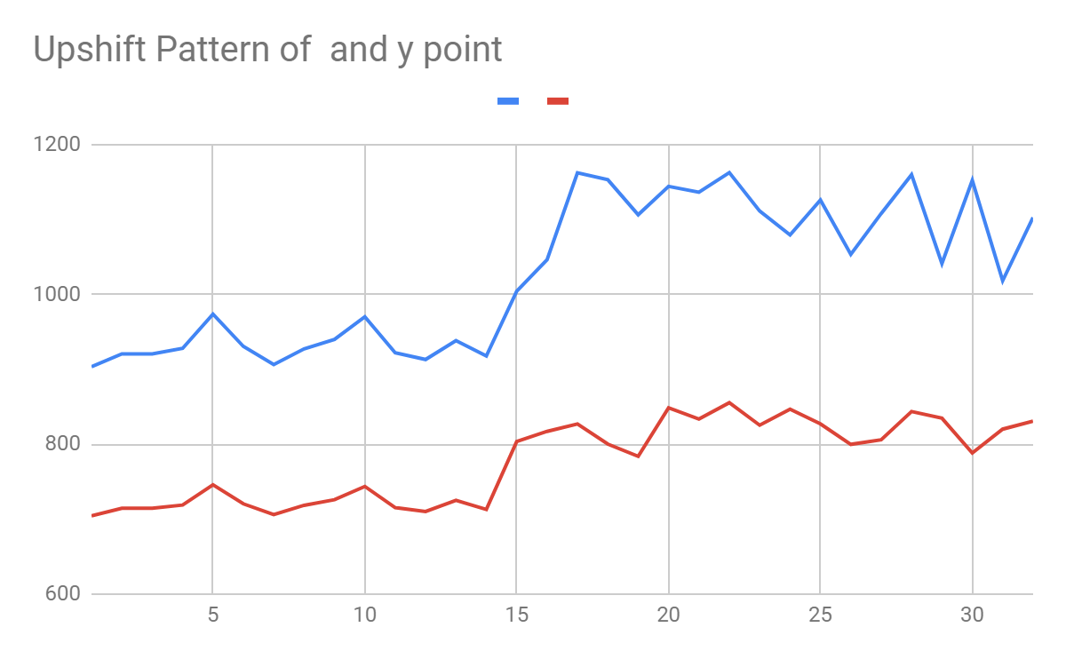

1. **Downshift Pattern**

|  |  |  |
| --- | --- | --- |
| **Recording timestamp** | **X point** | **Y point** |
| 0 | 923.7816758 | 716.4565129 |
| 10 | 929.8392273 | 720.0244054 |
| 20 | 970.7233212 | 744.1051013 |
| 30 | 945.6594385 | 729.3424962 |
| 40 | 955.2585289 | 734.9963521 |
| 50 | 969.1154816 | 743.1580852 |
| 60 | 964.5930908 | 740.4944009 |
| 70 | 973.5397367 | 745.7639676 |
| 80 | 910.4601762 | 708.6101611 |
| 90 | 936.1364904 | 723.733488 |
| 100 | 929.7802857 | 719.9896889 |
| 110 | 912.8748975 | 710.0324299 |
| 120 | 792.9126791 | 646.1177037 |
| 130 | 928.9234863 | 719.4850348 |
| 140 | 932.0498586 | 721.3264654 |
| 150 | 928.5618123 | 719.2720091 |
| 160 | 816.3878212 | 626.8169179 |
| 390 | 797.9979802 | 676.927676 |
| 400 | 875.616389 | 660.2661519 |
| 410 | 824.5875823 | 629.0987229 |
| 420 | 848.143174 | 649.0772673 |
| 430 | 849.6526015 | 668.8021168 |
| 440 | 841.7225591 | 651.0169603 |
| 450 | 762.5979329 | 617.0845728 |
| 460 | 848.6035503 | 649.3222681 |
| 470 | 839.6243202 | 662.4864291 |
| 480 | 857.1117093 | 630.6329847 |
| 490 | 755.2954874 | 608.8862406 |
| 500 | 802.2981419 | 619.6098975 |
| 510 | 689.5716369 | 620.3061303 |
| 520 | 757.8026515 | 667.4367326 |
| 530 | 820.6319454 | 671.804874 |

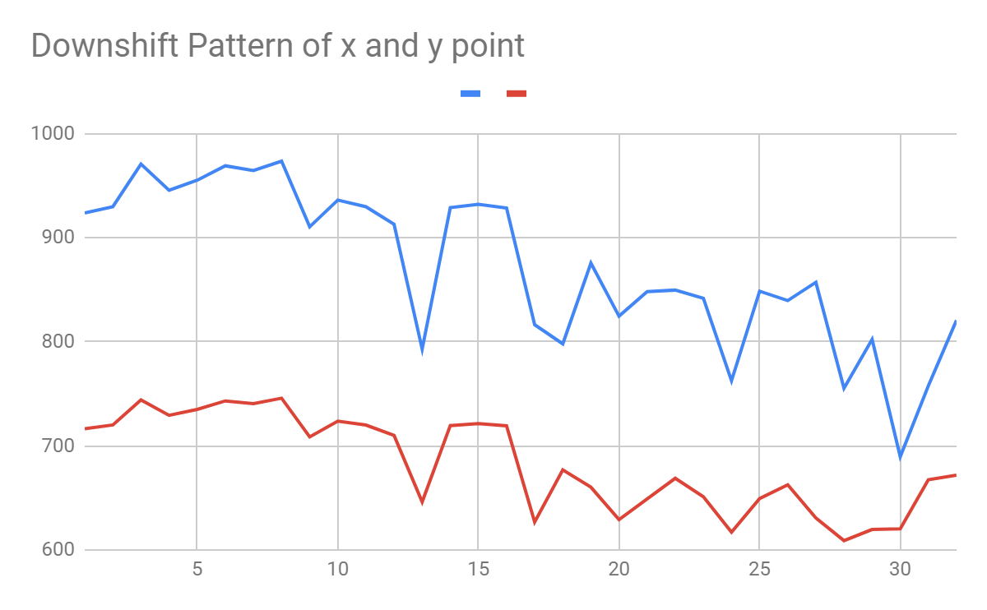

1. **Uptrend Pattern**

|  |  |  |
| --- | --- | --- |
| **Recording timestamp** | **X point** | **Y point** |
| 0 | 979.4391915 | 747.0488937 |
| 10 | 994.7536456 | 765.8138508 |
| 20 | 1001.716588 | 775.323962 |
| 30 | 1032.437839 | 752.7039545 |
| 40 | 959.8244126 | 720.0937983 |
| 50 | 1017.558355 | 758.3859534 |
| 60 | 1044.268756 | 771.3930328 |
| 70 | 1051.481854 | 749.34213 |
| 80 | 1011.00666 | 788.1421774 |
| 90 | 1027.779815 | 816.43105 |
| 100 | 1130.902079 | 856.9568871 |
| 110 | 1092.528748 | 790.9640105 |
| 120 | 1139.114622 | 819.9592775 |
| 130 | 1126.704716 | 771.4487325 |
| 140 | 1057.194329 | 799.8409241 |
| 150 | 1228.679084 | 826.9372722 |
| 160 | 1072.792312 | 805.6514786 |
| 390 | 1106.341826 | 886.6686405 |
| 400 | 1089.751781 | 818.2796354 |
| 410 | 1085.09116 | 819.689884 |
| 420 | 1082.673164 | 920.9457945 |
| 430 | 1127.525302 | 952.7600653 |
| 440 | 1319.150867 | 816.9574198 |
| 450 | 1092.437368 | 908.5968437 |
| 460 | 1390.702856 | 869.9814253 |
| 470 | 1120.481792 | 1018.822532 |
| 480 | 1183.98345 | 896.4355001 |
| 490 | 1140.629218 | 1012.02542 |
| 500 | 1446.971985 | 1001.867411 |
| 510 | 1125.882865 | 869.0564636 |
| 520 | 1431.702684 | 808.5423056 |
| 530 | 1094.828165 | 1054.849113 |

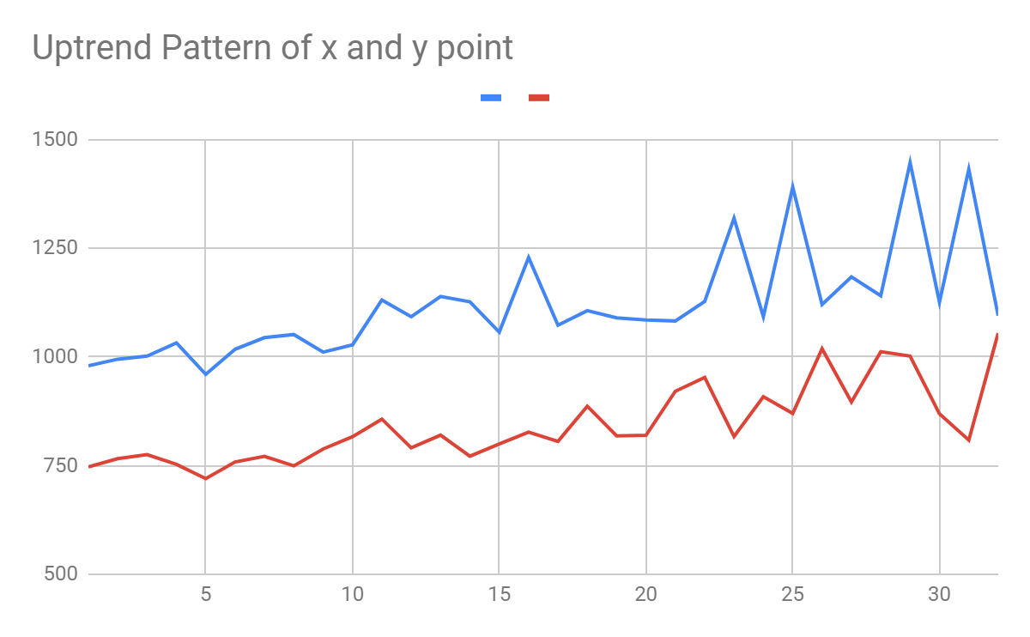

1. **Downtrend Patterns**

|  |  |  |
| --- | --- | --- |
| **Recording timestamp** | **X point** | **Y point** |
| 0 | 889.3562539 | 701.3414729 |
| 10 | 914.2088142 | 710.6022874 |
| 20 | 952.0926205 | 723.3755302 |
| 30 | 958.724668 | 711.9407709 |
| 40 | 857.4379502 | 672.1190792 |
| 50 | 876.7210738 | 662.3273336 |
| 60 | 855.7515331 | 631.5960983 |
| 70 | 890.0530758 | 678.7129131 |
| 80 | 857.8145847 | 683.1682255 |
| 90 | 882.0685052 | 649.7423896 |
| 100 | 776.5262158 | 656.8808221 |
| 110 | 746.3396812 | 609.7721951 |
| 120 | 801.4297478 | 677.7514927 |
| 130 | 791.5508311 | 602.736671 |
| 140 | 661.814377 | 589.7088297 |
| 150 | 766.1083256 | 650.1216133 |
| 160 | 876.1487359 | 674.1930443 |
| 390 | 823.2348242 | 599.2003111 |
| 400 | 648.6570139 | 669.2052631 |
| 410 | 714.6375467 | 612.6795715 |
| 420 | 690.1968193 | 555.5218088 |
| 430 | 833.0321457 | 557.4043896 |
| 440 | 777.6642043 | 463.0171603 |
| 450 | 784.9305952 | 480.9443178 |
| 460 | 523.0119553 | 601.425171 |
| 470 | 547.5398568 | 466.9213381 |
| 480 | 537.9106011 | 566.9893835 |
| 490 | 457.607207 | 410.7875517 |
| 500 | 549.3596324 | 541.5297169 |
| 510 | 396.9614919 | 570.7752728 |
| 520 | 577.5794077 | 480.7884019 |
| 530 | 592.1015411 | 526.9335028 |

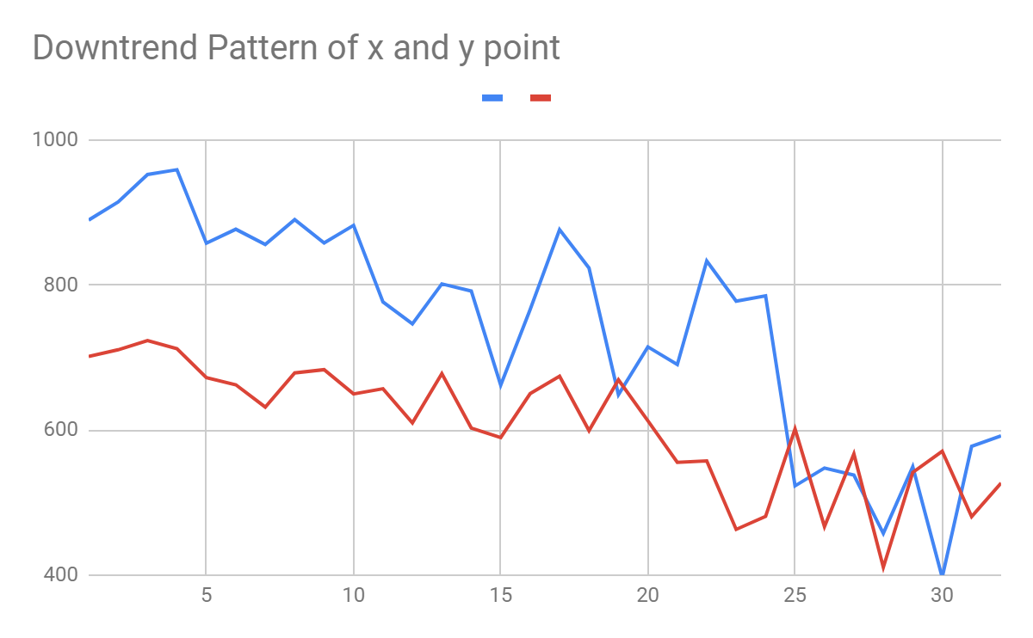

Similarly we prepared 8 different pattern datasets for each 32 time span of raw eye data.And by doing this I have **prepared 342 datasets for each patterns in which 300 datasets used for training and 42 datasets used for Testing.**

And after training the datasets on **5 different models** I have got the following results :

**Results**

I have trained the datasets (raweyedata) on five models:

1. ANN
2. 1 layer 1D CNN
3. 2 layer 1D-CNN
4. 3 layer 1D-CNN
5. Improved 1-D CNN (having inception layer)

And test these models on test datasets and compare the recognition accuracy of these five models.

1. **Accuracy**

|  |  |  |  |  |  |
| --- | --- | --- | --- | --- | --- |
| Model | ANN | 1 layer 1D CNN | 2 layer 1D CNN | 3 layer 1D CNN | Improved 1-D CNN |
| Accuracy on train data | 0.8062 | 0.84 | 0.889 | 0.835 | 0.90625 |
| Accuracy on test data | 0.786 | 0.839 | 0.857 | 0.7738 | 0.881 |

1. **Loss**

|  |  |  |  |  |  |
| --- | --- | --- | --- | --- | --- |
| Model | ANN | 1 layer 1D CNN | 2 layer 1D CNN | 3 layer 1D CNN | Improved 1-D CNN |
| Loss on train data | 0.388 | 0.30 | 0.2955 | 0.33 | 0.2466 |
| Loss on test data | 0.6682 | 0.336 | 0.3122 | 0.79 | 0.2761 |

1. **Confusion matrix**

**ANN**

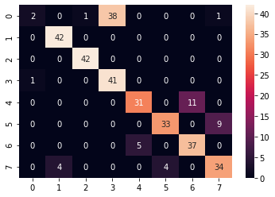

**1 layer 1-D CNN**

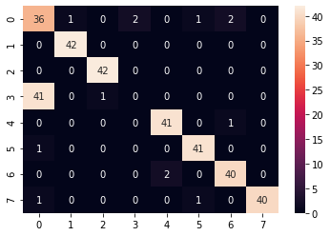

**2 layer 1-D CNN**

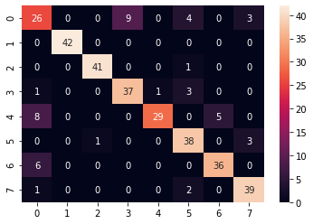

**3 layer 1-D CNN**

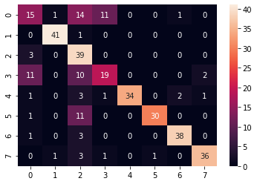

**Improved 1-D CNN**

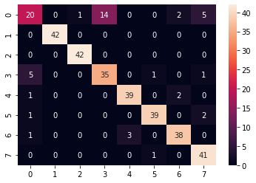

1. **Graph between training and validation loss of Models per epoch:**
2. **ANN**

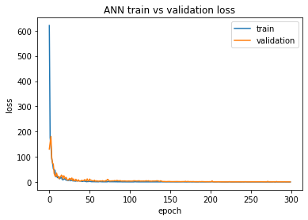

**B. 1 layer 1-D CNN**

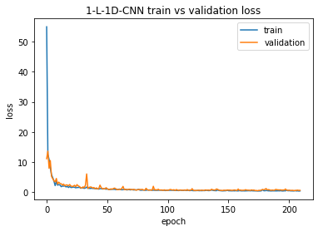

**C. 2 layer 1-D CNN**

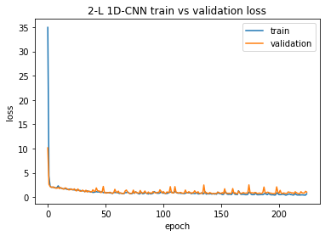

**D. 3 layer 1-D CNN**

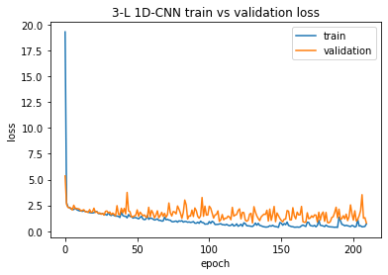

**E. Improved 1-D CNN ( having inception layer)**

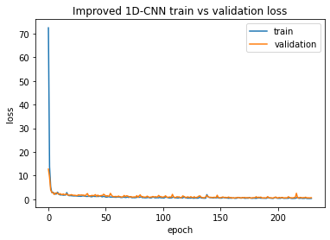

**4. Graph between accuracy of train and validation data of each model per epoch**

1. **ANN**

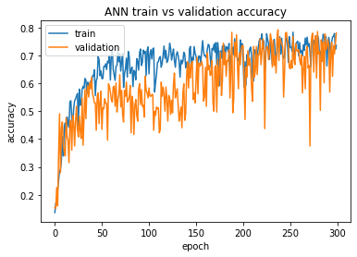

1. **1 layer 1D-CNN**

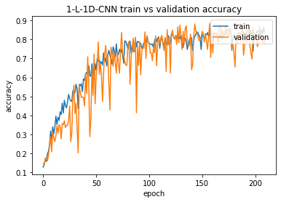

1. **2 layer 1D-CNN**

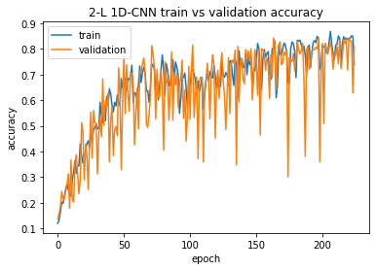

1. **3 layer 1D-CNN**

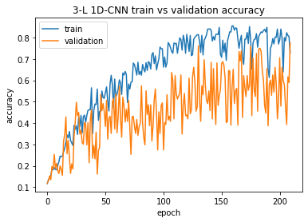

1. **Improved 1D-CNN (Inception layer)**

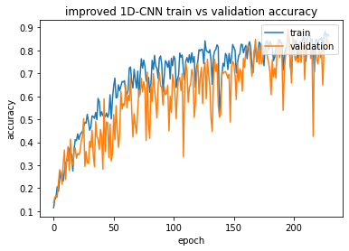

**Conclusion:**

After analyzing the results like accuracy , loss , confusion matrix and all the plots of loss and accuracy for training and validation datasets , Improved 1D-CNN have highest recognition accuracy of 90% on train data and 88% on Test data compared to other models.

The result shows that CNN with an introduction of ‘inception’ structure achieves higher recognition accuracy than purely layer-by-layer CNN.